 

**Submitted By : Submitted to :**

**Sudhanshu Dubey Mrs. Rajni Verma**

**XII A – SCIENCE PGT (Comp. Sc. )**

**CBSE ROLL NO: 2728863**

**Session – 2016-17**

1

On

Library Management System



**CERTIFICATE**

This is to certify that Master **Sudhanshu Dubey**, of class **XII A** , CBSE roll no. 2728863, has satisfactorily completed the Computer Science investigatory project on **LIBRARY MANAGEMENT SYSTEM** for the academic year 2016-2017.

I wish him success in life.

**INTERNAL EXAMINER EXTERNAL EXAMINER**

1

 **ACKNOWLEDGEMENT**

**First and foremost, I thank god for having given me the strength and courage for the successful completion of this project work.**

**I wish to express my sincere gratitude to Shri. H. K. Nirmal, Principal, Kendriya Vidyalaya No. 2 AFS Halwara, Ludhiana who has provided me with well equipped labs.**

**I wish to express my deep and profound sense of gratitude to my Computer Science teacher Mrs. Rajni Verma (PGT Computer Science) for having given me valuable support, encouragement and assistance towards producing a successful project.**

**I would also like to extend my sincere thanks to my parents for their valuable support and cooperation which helped me a lot in carrying out this project work successfully.**

2

**Sudhanshu Dubey**

**Class XII A**



INDEX

**1) Introduction…………………………………………………………................ 4**

**2) Objective of Project & System Implementation……... 5**

**3) Header files used.………………………………………...………………….. 6**

**4) Classes……………………………………………………………………............... 7**

**5) Functions…………………………………………………………………………….. 9**

**6) Source code………….…………………………………………….................. 10**

**7) Outputs……………………………………………………………………………….. 26**

**8) Bibliography……………………………………………………………….. 33**

3



**INTRODUCTION**

* **This Library Management System project is for monitoring and controlling the transactions in a library.**
* **It mainly focuses on basic operations in a library like adding new members, new books, and updating new information, searching books and members and provides facility to borrow and return books.**
* **We can enter the record of new books and retrieve the details of books available in the library.**
* **We can issue the books to the students and maintain their records.**
* **Late fine is charged for students who return the issued books after the due date.**
* **Only one book is issued to students at a time.**
* **New Book is not issued to students who have not returned the last book.**

4

**Objective of Project**

* The objective of the project is to computerise the functions of the Library.
* Computerisation helps in better record keeping and management of the Library.
* This simplifies the work of the Librarian as he/she is able to keep a better check on which book is issued by which student.
* Newly arrived books can easily be added, and data about any book can easily be modified with the help of this project.
* Also, records can be transferred from one system to the other without any loss of information.

System Implementation

The Hardware Used :

While developing the software, the hardware used are :

PC with Intel Core 2 Duo processor having 2.00 GB RAM , 500 GB Hard Disk, SVGA and other required devices.

The Software Used :

* Microsoft Windows® 8 as Operating System.
* TurboC 7 v2.1 for coding.
* MS-Word 2010 for documentation.

**HEADER FILES USED**

#include<fstream.h>

#include<conio.h>

#include<stdio.h>

#include<process.h>

#include<string.h>

#include<iomanip.h>

CLASSES

1. **Class book**

**PRIVATE MEMBERS**

**Data members**

**bno : char type (6 characters)**

**bname : char type (50 characters)**

**aname : char type (20 characters)**

**PUBLIC MEMBERS**

**Functions**

**create_book() : to read bno, bname & aname and create book.**

**show_book() : to display details of the book when it is issued.**

**modify_book() : to modify the name & author of the**

**bookretbno() : to return bno**

**2) CLASS STUDENT**

**PRIVATE MEMBERS**

**Data members**

**Admno : char type (6 characters)**

**name : char type (20 characters)**

**stbno : char type (6 characters)**

**token : integer type**

**PUBLIC MEMBERS**

**Functions**

**create_student() : to create student record.**

**show_student() : to display a specific student record.**

**modify_student() : to modify student’s name.**

**retadmno() : to return admission no. of student.**

**retstbno() : to return the issued book no.**

**addtoken() : to store the value of token as 1 book is**

**issued.**

**resettoken() : to reset the value of token to 0 is book is returned.**

FUNCTIONS

1. **functions to write in file**

* **write_book()**
* **write_student()**

1. **functions to read specific record from file**

* **display_spb()**
* **display_sps()**

1. **function to modify record of file**

* **modify_book()**
* **modify_student()**

1. **function to delete record from file**

* **delete_student()**
* **delete_book()**

1. **function to display all record lists**

* **display_alls()**
* **display_allb()**

1. **Other functions**

* **book_issue() : function to issue book**
* **book_deposit() : function to deposit book**
* **intro() : Introduction function**
* **admin_menu() : Administrator menu function**

**SOURCE CODE**

**//****************************************************************************************************//**

**HEADER FILES USED IN PROJECT**

**//****************************************************************************************************//**

**#include<fstream.h>**

**#include<conio.h>**

**#include<stdio.h>**

**#include<process.h>**

**#include<string.h>**

**#include<iomanip.h>**

**//****************************************************************************************************//**

**CLASSES USED IN PROJECT**

**//****************************************************************************************************//**

**class book**

**{**

**char bno[6];**

**char bname[50];**

**char aname[20];**

**public:**

**void create_book()**

**{**

**cout<<"\nNEW BOOK ENTRY...\n";**

**cout<<"\nEnter The book no.";**

**cin>>bno;**

**cout<<"\n\nEnter The Name of The Book ";**

**gets(bname);**

**cout<<"\n\nEnter The Author's Name ";**

**gets(aname);**

**cout<<"\n\n\nBook Created..";**

**}**

**void show_book()**

**{**

**cout<<"\nBook no. : ";**

**cout<<bno;**

**cout<<"\nBook Name : ";**

**puts(bname);**

**cout<<"Author Name : ";**

**puts(aname);**

**}**

**void modify_book()**

**{**

**cout<<"\nBook no. : "<<bno;**

**cout<<"\nModify Book Name : ";**

**gets(bname);**

**cout<<"\nModify Author's Name of Book:";**

**gets(aname);**

**}**

**char* retbno()**

**{**

**return bno;**

**}**

**void report()**

**{**

**cout<<bno<<setw(30)<<bname<<setw(30)<<aname<<endl;**

**}**

**}; //CLASS BOOK ENDS HERE**

**class student**

**{**

**char admno[6];**

**char name[20];**

**char stbno[6];**

**int token;**

**public:**

**void create_student()**

**{**

**clrscr();**

**cout<<"\nNEW STUDENT ENTRY...\n";**

**cout<<"\nEnter The admission no. ";**

**cin>>admno;**

**cout<<"\n\nEnter The Name of the student";**

**gets(name);**

**token=0;**

**stbno[0]='/0';**

**cout<<"\n\nStudent Record Created..";**

**}**

**void show_student()**

**{**

**cout<<"\nAdmission no. : ";**

**cout<<admno;**

**cout<<"\nStudent Name : ";**

**puts(name);**

**cout<<"\nNo of Book issued : "<<token;**

**if(token==1)**

**{**

**cout<<"\nBook No "<<stbno;**

**}**

**}**

**void modify_student()**

**{**

**cout<<"\nAdmission no. : "<<admno;**

**cout<<"\nModify Student Name : ";**

**gets(name);**

**}**

**char* retadmno()**

**{**

**return admno;**

**}**

**char* retstbno()**

**{**

**return stbno;**

**}**

**int rettoken()**

**{**

**return token;**

**}**

**void addtoken()**

**{**

**token=1;**

**}**

**void resettoken()**

**{**

**token=0;**

**}**

**void getstbno(char t[])**

**{**

**strcpy(stbno,t);**

**}**

**void report()**

**{**

**cout<<"\t"<<admno<<setw(20)<<name<<setw(10);**

**cout<<token<<endl;**

**}**

**}; //CLASS STUDENT ENDS HERE**

**//**********************************************************//**

**GLOBAL DECLARATION FOR STREAM OBJECT**

**//**********************************************************//**

**fstream fp,fp1;**

**book bk;**

**student st;**

**//**********************************************************//**

**FUNCTIONS TO WRITE IN FILE**

**//**********************************************************//**

**void write_book()**

**{**

**char ch;**

**fp.open("book.dat",ios::out|ios::app);**

**do**

**{**

**clrscr();**

**bk.create_book();**

**fp.write((char*)&bk,sizeof(book));**

**cout<<"\n\nDo you want to add more record..(y/n?)";**

**cin>>ch;**

**} while(ch=='y'||ch=='Y');**

**fp.close();**

**}**

**void write_student()**

**{**

**char ch;**

**fp.open("student.dat",ios::out|ios::app);**

**do**

**{**

**st.create_student();**

**fp.write((char*)&st,sizeof(student));**

**cout<<"\n\ndo you want to add more record..(y/n?)";**

**cin>>ch;**

**} while(ch=='y'||ch=='Y');**

**fp.close();**

**}**

**//**********************************************************//**

**FUNCTION TO READ SPECIFIC RECORD FROM FILE**

**//**********************************************************//**

**void display_spb(char n[])**

**{**

**cout<<"\nBOOK DETAILS\n";**

**int flag=0;**

**fp.open("book.dat",ios::in);**

**while(fp.read((char*)&bk,sizeof(book)))**

**{**

**if(strcmpi(bk.retbno(),n)==0)**

**{**

**bk.show_book();**

**flag=1;**

**}**

**}**

**fp.close();**

**if(flag==0)**

**{**

**cout<<"\n\nBook does not exist";**

**}**

**getch();**

**}**

**void display_sps(char n[])**

**{**

**cout<<"\nSTUDENT DETAILS\n";**

**int flag=0;**

**fp.open("student.dat",ios::in);**

**while(fp.read((char*)&st,sizeof(student)))**

**{**

**if((strcmpi(st.retadmno(),n)==0))**

**{**

**st.show_student();**

**flag=1;**

**}**

**}**

**fp.close();**

**if(flag==0)**

**{**

**cout<<"\n\nStudent does not exist";**

**}**

**getch();**

**}**

**//*****************************************************//**

**FUNCTION TO MODIFY RECORD OF FILE**

**//*****************************************************//**

**void modify_book()**

**{**

**char n[6];**

**int found=0;**

**clrscr();**

**cout<<"\n\n\tMODIFY BOOK REOCORD.... ";**

**cout<<"\n\n\tEnter The book no. of The book";**

**cin>>n;**

**fp.open("book.dat",ios::in|ios::out);**

**while(fp.read((char*)&bk,sizeof(book)) && found==0)**

**{**

**if(strcmpi(bk.retbno(),n)==0)**

**{**

**bk.show_book();**

**cout<<"\nEnter The New Details of book”; cout<<endl;**

**bk.modify_book();**

**int pos=-1*sizeof(bk);**

**fp.seekp(pos,ios::cur);**

**fp.write((char*)&bk,sizeof(book));**

**cout<<"\n\n\t Record Updated";**

**found=1;**

**}**

**}**

**fp.close();**

**if(found==0)**

**{**

**cout<<"\n\n Record Not Found ";**

**}**

**getch();**

**}**

**void modify_student()**

**{**

**char n[6];**

**int found=0;**

**clrscr();**

**cout<<"\n\n\tMODIFY STUDENT RECORD... ";**

**cout<<"\n\n\tEnter The admission no. of The student";**

**cin>>n;**

**fp.open("student.dat",ios::in|ios::out);**

**while(fp.read((char*)&st,sizeof(student)) && found==0)**

**{**

**if(strcmpi(st.retadmno(),n)==0)**

**{**

**st.show_student();**

**cout<<"\nEnter The New Details of student";**

**cout<<endl;**

**st.modify_student();**

**int pos=-1*sizeof(st);**

**fp.seekp(pos,ios::cur);**

**fp.write((char*)&st,sizeof(student));**

**cout<<"\n\n\t Record Updated";**

**found=1;**

**}**

**}**

**fp.close();**

**if(found==0)**

**{**

**cout<<"\n\n Record Not Found ";**

**}**

**getch();**

**}**

**//********************************************************//**

**FUNCTION TO DELETE RECORD OF FILE**

**//********************************************************//**

**void delete_student()**

**{**

**char n[6];**

**int flag=0;**

**clrscr();**

**cout<<"\n\n\n\tDELETE STUDENT...";**

**cout<<"\n\nEnter The admission no. of the Student you”;**

**cout<<"want To Delete : ";**

**cin>>n;**

**fp.open("student.dat",ios::in|ios::out);**

**fstream fp2;**

**fp2.open("Temp.dat",ios::out);**

**fp.seekg(0,ios::beg);**

**while(fp.read((char*)&st,sizeof(student)))**

**{**

**if(strcmpi(st.retadmno(),n)!=0)**

**{**

**fp2.write((char*)&st,sizeof(student));**

**}**

**else**

**{**

**flag=1;  
 }**

**}**

**fp2.close();**

**fp.close();**

**remove("student.dat");**

**rename("Temp.dat","student.dat");**

**if(flag==1)**

**{**

**cout<<"\n\n\tRecord Deleted ..";**

**}**

**else**

**{**

**cout<<"\n\nRecord not found";**

**}**

**getch();**

**}**

**void delete_book()**

**{**

**char n[6];**

**clrscr();**

**cout<<"\n\n\n\tDELETE BOOK ...";**

**cout<<"\n\nEnter The Book no. of the Book You Want To “; cout<<"Delete: ";**

**cin>>n;**

**fp.open("book.dat",ios::in|ios::out);**

**fstream fp2;**

**fp2.open("Temp.dat",ios::out);**

**fp.seekg(0,ios::beg);**

**while(fp.read((char*)& bk,sizeof(book)))**

**{**

**if(strcmpi(bk.retbno(),n)!= 0)**

**{**

**fp2.write((char*)&bk,sizeof(book));**

**}**

**}**

**fp2.close();**

**fp.close();**

**remove("book.dat");**

**rename("Temp.dat","book.dat");**

**cout<<"\n\n\tRecord Deleted ..";**

**getch();**

**}**

**//********************************************************//**

**FUNCTION TO DISPLAY ALL STUDENTS LIST**

**//********************************************************//**

**void display_alls()**

**{**

**clrscr();**

**fp.open("student.dat",ios::in);**

**if(!fp)**

**{**

**cout<<"ERROR!!! FILE COULD NOT BE OPEN ";**

**getch();**

**return;**

**}**

**cout<<"\n\n\t\tSTUDENT LIST\n\n";**

**cout<<"##############################################\n";**

**cout<<"\tAdmissionNo.";**

**cout<<<<setw(10)<<"Name"<<setw(20)<<"Book Issued\n";**

**cout<<"##############################################\n";**

**while(fp.read((char*)&st,sizeof(student)))**

**{**

**st.report();**

**}**

**fp.close();**

**getch();**

**}**

**//**********************************************************//**

**FUNCTION TO DISPLAY BOOKS LIST**

**//**********************************************************//**

**void display_allb()**

**{**

**clrscr();**

**fp.open("book.dat",ios::in);**

**if(!fp)**

**{**

**cout<<"ERROR!!! FILE COULD NOT BE OPEN ";**

**getch();**

**return;**

**}**

**cout<<"\n\n\t\tBook LIST\n\n";**

**cout<<"##############################################\n";**

**cout<<"BookNumber"<<setw(20)<<"BookName"<<setw(25);**

**cout<<"Author\n";**

**cout<<"##############################################\n";**

**while(fp.read((char*)&bk,sizeof(book)))**

**{**

**bk.report();**

**}**

**fp.close();**

**getch();**

**}**

**//********************************************************//**

**FUNCTION TO ISSUE BOOK**

**//********************************************************//**

**void book_issue()**

**{**

**char sn[6],bn[6];**

**int found=0,flag=0;**

**clrscr();**

**cout<<"\n\nBOOK ISSUE ...";**

**cout<<"\n\n\tEnter The student's admission no.";**

**cin>>sn;**

**fp.open("student.dat",ios::in|ios::out);**

**fp1.open("book.dat",ios::in|ios::out);**

**while(fp.read((char*)&st,sizeof(student))&& found==0)**

**{**

**if(strcmpi(st.retadmno(),sn)==0)**

**{**

**found=1;**

**if(st.rettoken()==0)**

**{**

**cout<<"\n\n\tEnter the book no. ";**

**cin>>bn;**

**while(fp1.read((char*)&bk,sizeof(book))&& flag==0)**

**{**

**if(strcmpi(bk.retbno(),bn)==0)**

**{**

**bk.show_book();**

**flag=1;**

**st.addtoken();**

**st.getstbno(bk.retbno());**

**int pos=-1*sizeof(st);**

**fp.seekp(pos,ios::cur);**

**fp.write((char*)&st,sizeof(student);**

**cout<<"\n\n\t Book issued successfully";**

**cout<<"\n\nPlease Note: Write current";**

**cout<<"date in backside of book and";**

**cout<<"submit within 15 days\n.";**

**cout<<"Fine of Rs.1 for each day will be";**

**cout<<"taken after 15 days period";**

**}**

**}**

**if(flag==0)**

**{ cout<<"Book no. does not exist"; }**

**}**

**else**

**{**

**cout<<"You have not returned the last book.”;**

**cout<<" Book can be issued only after returning the”;**

**cout<<"previous one.";**

**}**

**}**

**if(found==0)**

**{ cout<<"Student record not exist..."; }**

**getch();**

**fp.close();**

**fp1.close();**

**}**

**//**********************************************************//**

**FUNCTION TO DEPOSIT BOOK**

**//*********************************************************//**

**void book_deposit()**

**{**

**char sn[6],bn[6];**

**int found=0,flag=0,day,fine;**

**clrscr();**

**cout<<"\n\nBOOK DEPOSIT ...";**

**cout<<"\n\n\tEnter The student’s admission no.";**

**cin>>sn;**

**fp.open("student.dat",ios::in|ios::out);**

**fp1.open("book.dat",ios::in|ios::out);**

**while(fp.read((char*)&st,sizeof(student)) && found==0)**

**{**

**if(strcmpi(st.retadmno(),sn)==0)**

**{**

**found=1;**

**if(st.rettoken()==1)**

**{**

**while(fp1.read((char*)&bk,sizeof(book))&& flag==0)**

**{**

**if(strcmpi(bk.retbno(),st.retstbno())==0)**

**{**

**bk.show_book();**

**flag=1;**

**cout<<"\n\nBook deposited in no. of days";**

**cin>>day;**

**if(day>15)**

**{**

**fine=(day-15)*1;**

**cout<<"\n\nFine has to deposited Rs";**

**cout<<fine;**

**}**

**st.resettoken();**

**int pos=-1*sizeof(st);**

**fp.seekp(pos,ios::cur);**

**fp.write((char*)&st,sizeof(student));**

**cout<<"\n\n\t Book deposited successfully";**

**}**

**}**

**if(flag==0)**

**{**

**cout<<"Book no does not exist";**

**}**

**else**

**{**

**cout<<"No book is issued..please check!!";**

**}**

**}**

**}**

**}**

**if(found==0)**

**cout<<"Student record not exist...";**

**getch();**

**fp.close();**

**fp1.close();**

**}**

**//***************************************************************//**

**INTRODUCTION FUNCTION**

**//***************************************************************//**

**void intro()**

**{**

**clrscr();**

**gotoxy(25,11);**

**cout<<"LIBRARY MANAGEMENT SYSTEM";**

**cout<<"\n\nMADE BY : $udhanshu Dubey";**

**cout<<"\n\nSCHOOL : KENDRIYA VIDYALAYA No.2 AFS HALWARA";**

**getch();**

**}**

**//***************************************************************//**

**ADMINISTRATOR MENU FUNCTION**

**//***************************************************************//**

**void admin_menu()**

**{**

**clrscr();**

**int ch2;**

**cout<<"\n\n\n\tADMINISTRATOR MENU";**

**cout<<"\n\n\t1.CREATE STUDENT RECORD";**

**cout<<"\n\n\t2.DISPLAY ALL STUDENTS RECORD";**

**cout<<"\n\n\t3.DISPLAY SPECIFIC STUDENT RECORD ";**

**cout<<"\n\n\t4.MODIFY STUDENT RECORD";**

**cout<<"\n\n\t5.DELETE STUDENT RECORD";**

**cout<<"\n\n\t6.CREATE BOOK ";**

**cout<<"\n\n\t7.DISPLAY ALL BOOKS ";**

**cout<<"\n\n\t8.DISPLAY SPECIFIC BOOK ";**

**cout<<"\n\n\t9.MODIFY BOOK ";**

**cout<<"\n\n\t10.DELETE BOOK ";**

**cout<<"\n\n\t11.BACK TO MAIN MENU";**

**cout<<"\n\n\tPlease Enter Your Choice (1-11): ";**

**cin>>ch2;**

**switch(ch2)**

**{**

**case 1: clrscr();**

**write_student();**

**break;**

**case 2: display_alls();**

**break;**

**case 3: char num[6];**

**clrscr();**

**cout<<"\n\n\tPlease Enter The Admission No. ";**

**cin>>num;**

**display_sps(num);**

**break;**

**case 4: modify_student();**

**break;**

**case 5: delete_student();**

**break;**

**case 6: clrscr();**

**write_book();**

**break;**

**case 7: display_allb();**

**break;**

**case 8: char num[6];**

**clrscr();**

**cout<<"\n\n\tPlease Enter The book No. ";**

**cin>>num;**

**display_spb(num);**

**break;**

**case 9: modify_book();**

**break;**

**case 10: delete_book();**

**break;**

**case 11: return;**

**default:**

**cout<<"\a";**

**}**

**admin_menu();**

**}**

**//***************************************************************//**

**THE MAIN FUNCTION OF PROGRAM**

**//***************************************************************//**

**void main()**

**{**

**char ch;**

**intro();**

**do**

**{**

**clrscr();**

**cout<<"\n\n\n\t MAIN MENU";**

**cout<<"\n\n\t01. ADMINISTRATOR MENU";**

**cout<<"\n\n\t02. BOOK ISSUE";**

**cout<<"\n\n\t03. BOOK DEPOSIT;**

**cout<<"\n\n\t04. EXIT";**

**cout<<"\n\n\tPlease Select Your Option (1-4): ";**

**ch=getche();**

**switch(ch)**

**{**

**case '1': clrscr();**

**admin_menu();**

**break;**

**case '2': book_issue();**

**break;**

**case '3': book_deposit();**

**break;**

**case '4': exit(0);**

**default : cout<<"\a";**

**}**

**} while(ch!='4');**

**}**

**//**********************************************************//**

**END OF CODE**

**//**********************************************************//**

OUTPUTS

1. 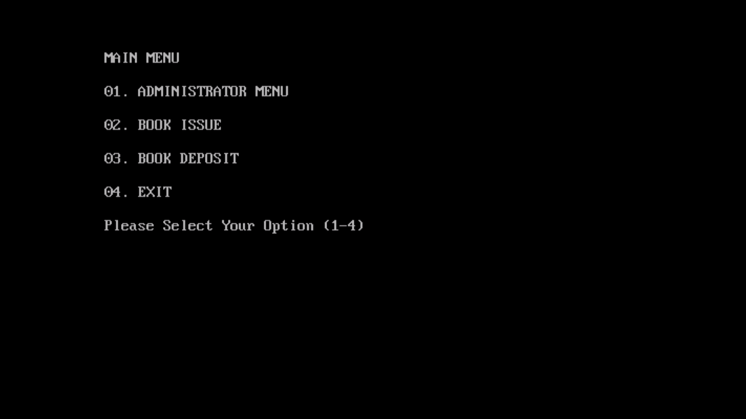Main menu
2. 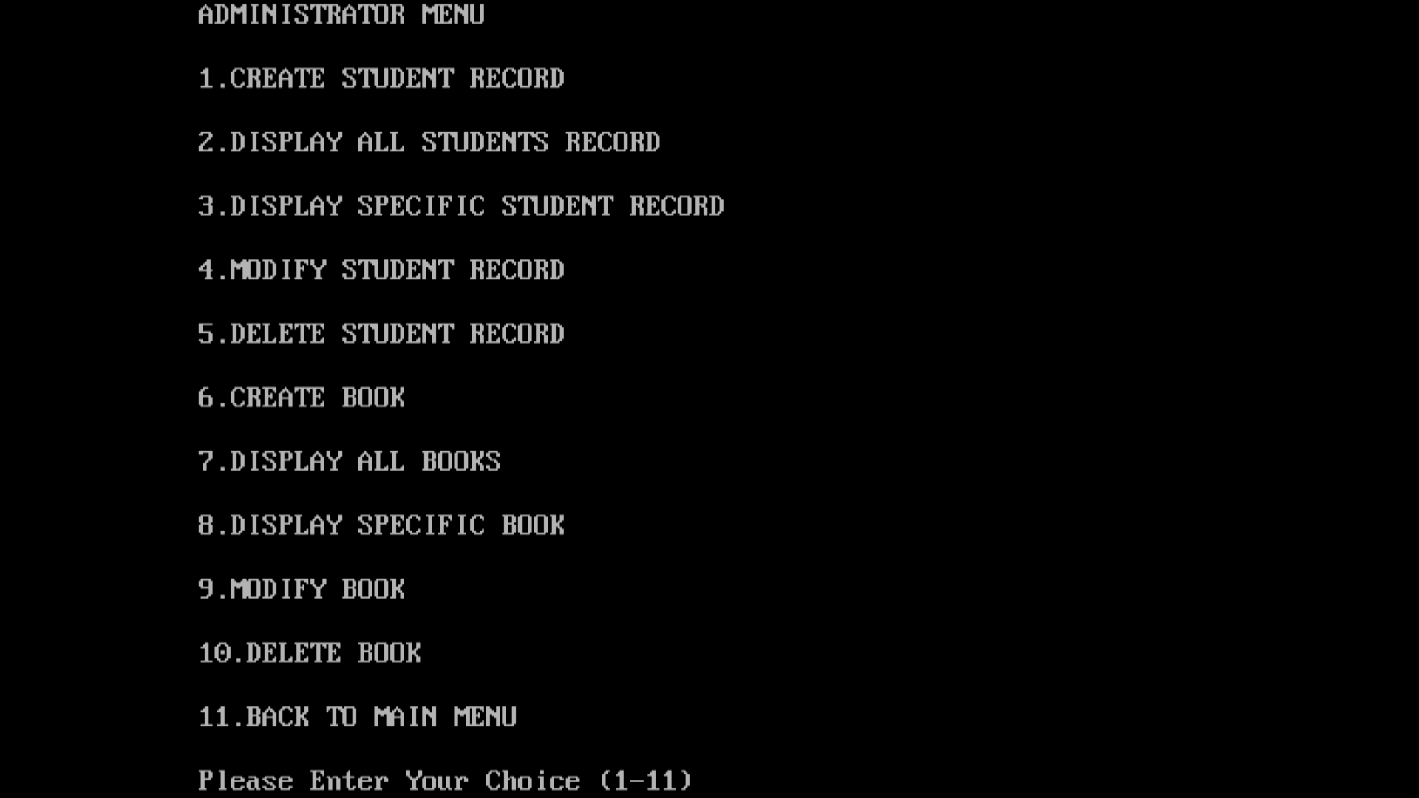Administrator Menu
3. Creating a Student record

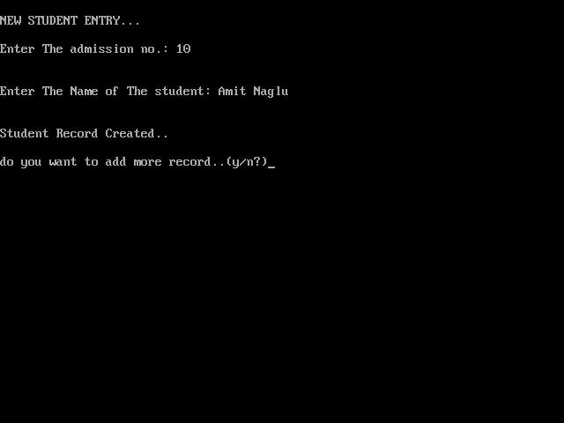

1. Displaying all the student’s record

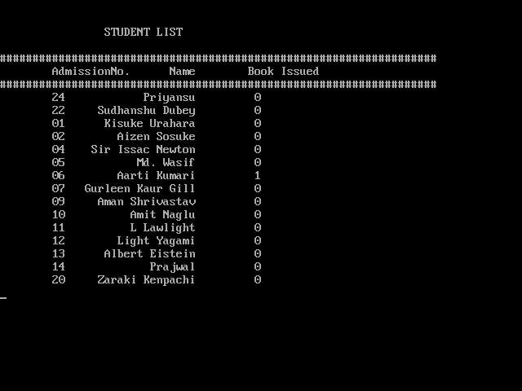

1. Displaying details of a specific student

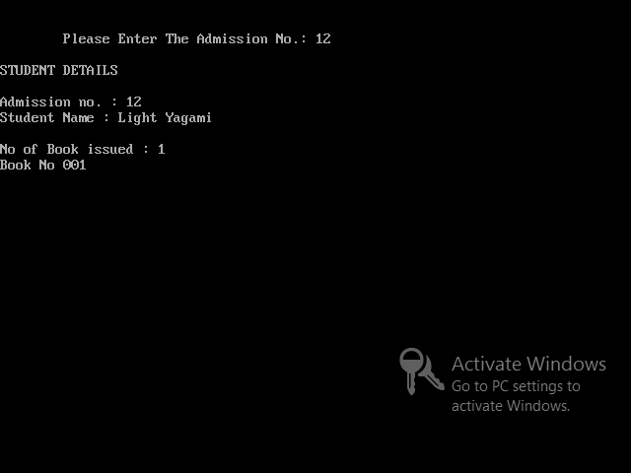

1. Modifying a student’s record

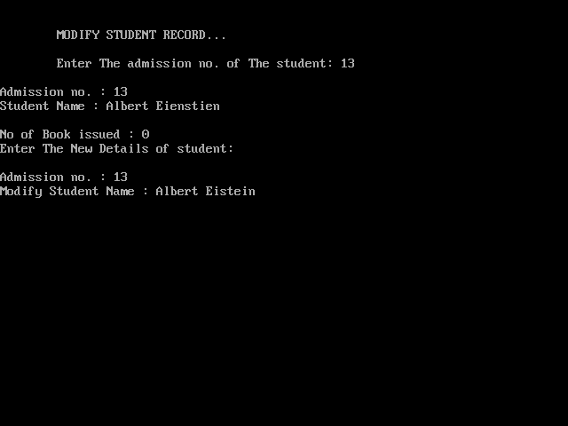

1. Deleting a student’s record

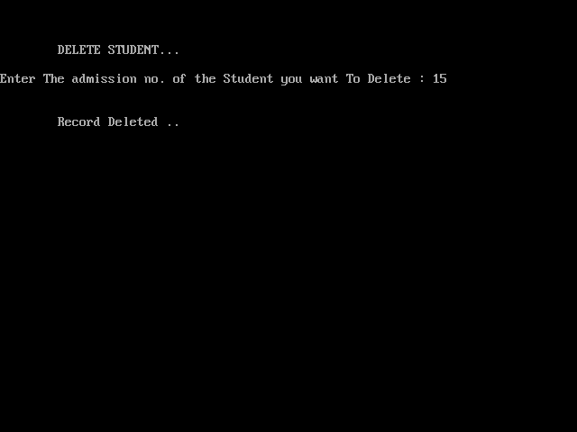

1. Entering a new book

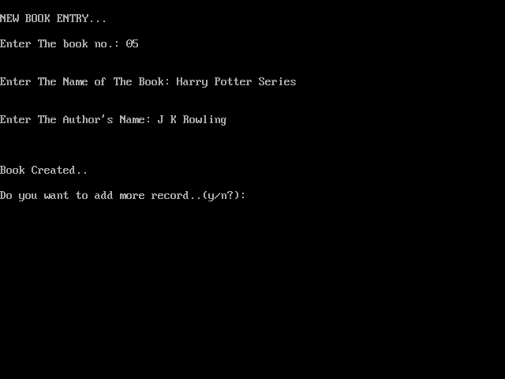

1. Displaying all the books

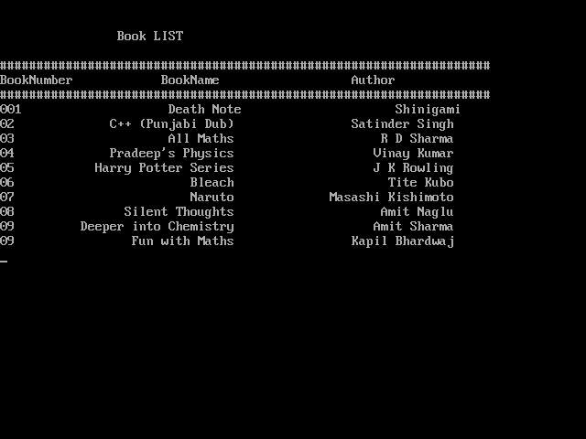

1. Displaying details of a specific book

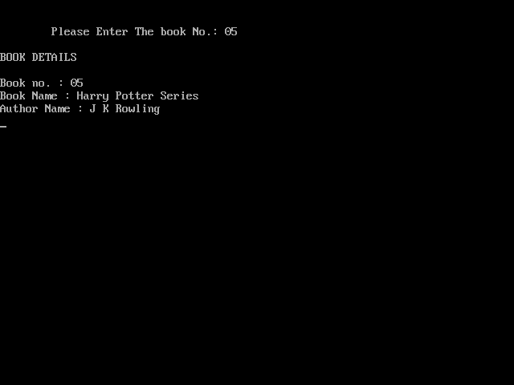

1. Modifying details of a book

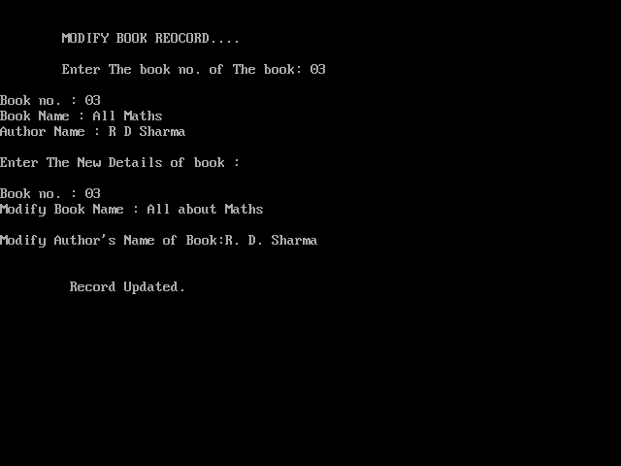

1. Deleting a book

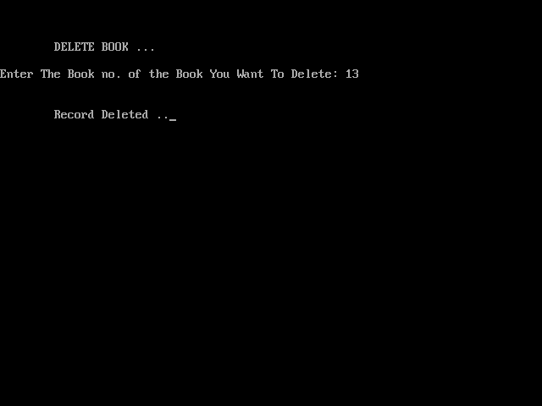

1. Issuing a book

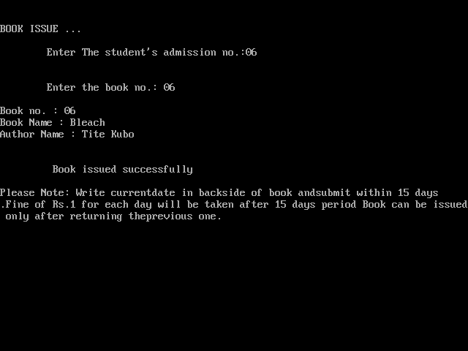

1. Depositing a book

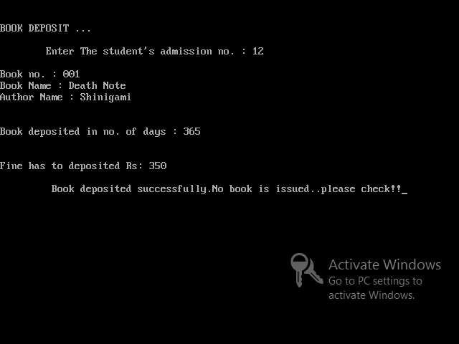



33

**Bibliography**

* **Computer Science Text Book for**

**Class XII by Sumita Arora**

* **www.cppforschool.com**
* [**www.icbse.com**](http://www.icbse.com)

* **google images**